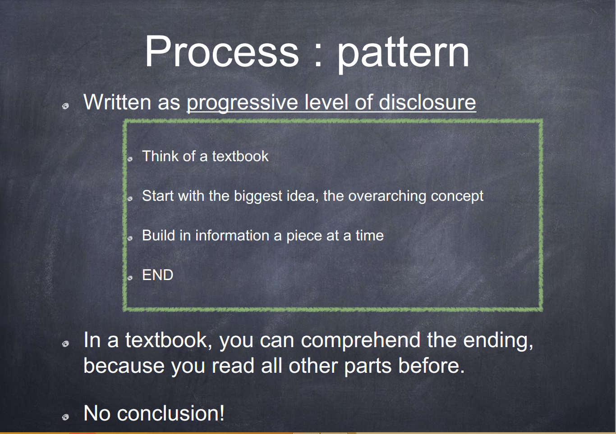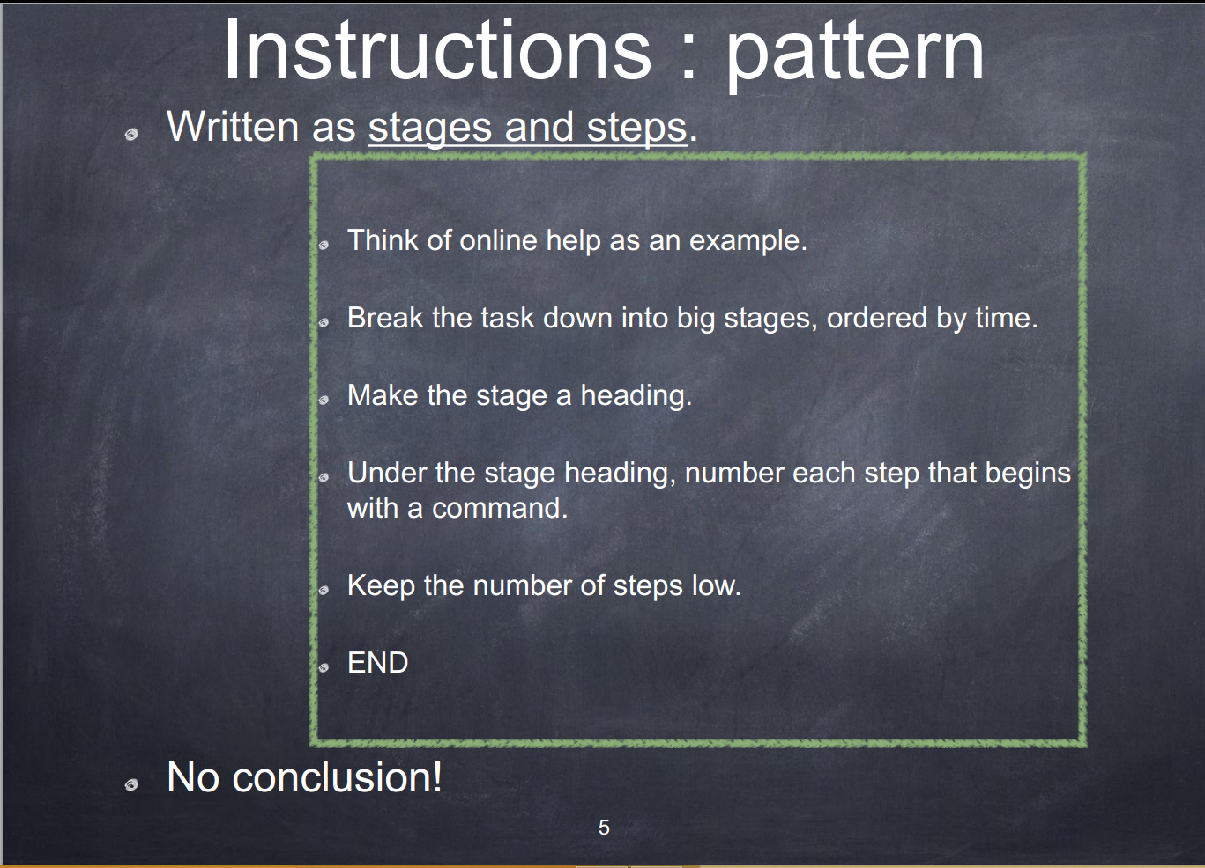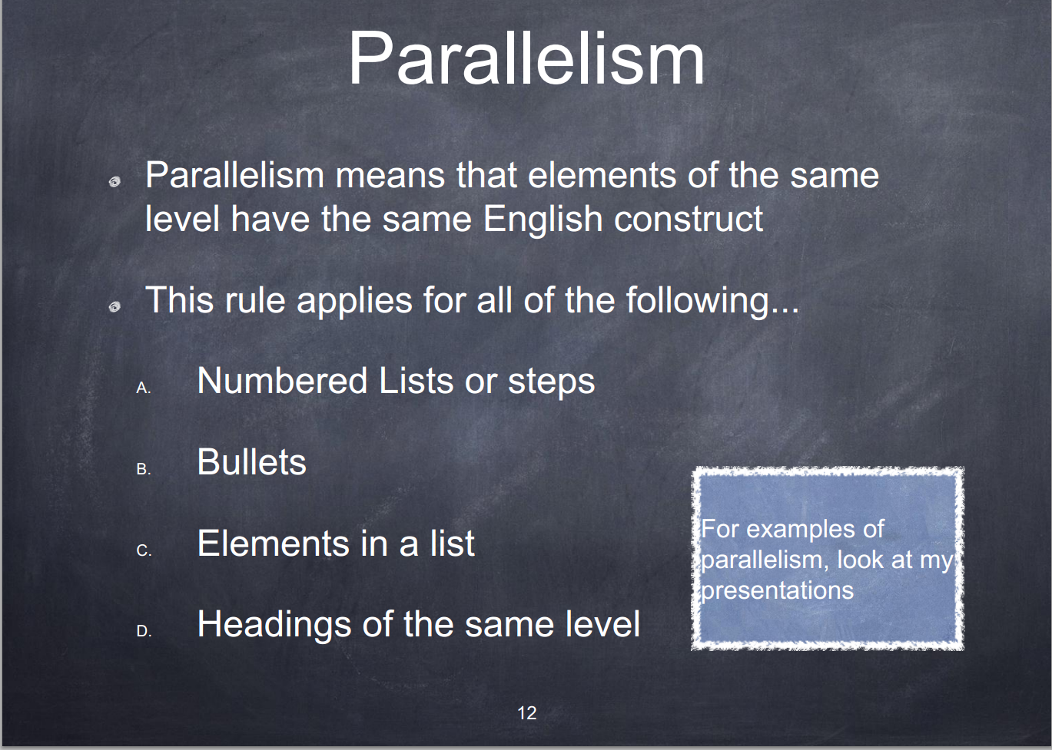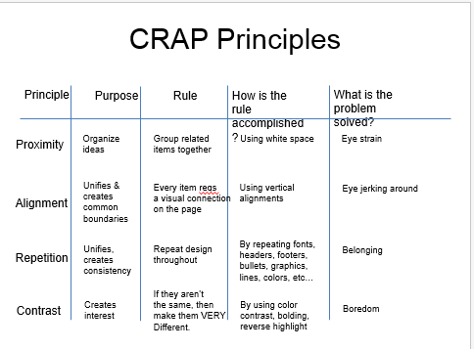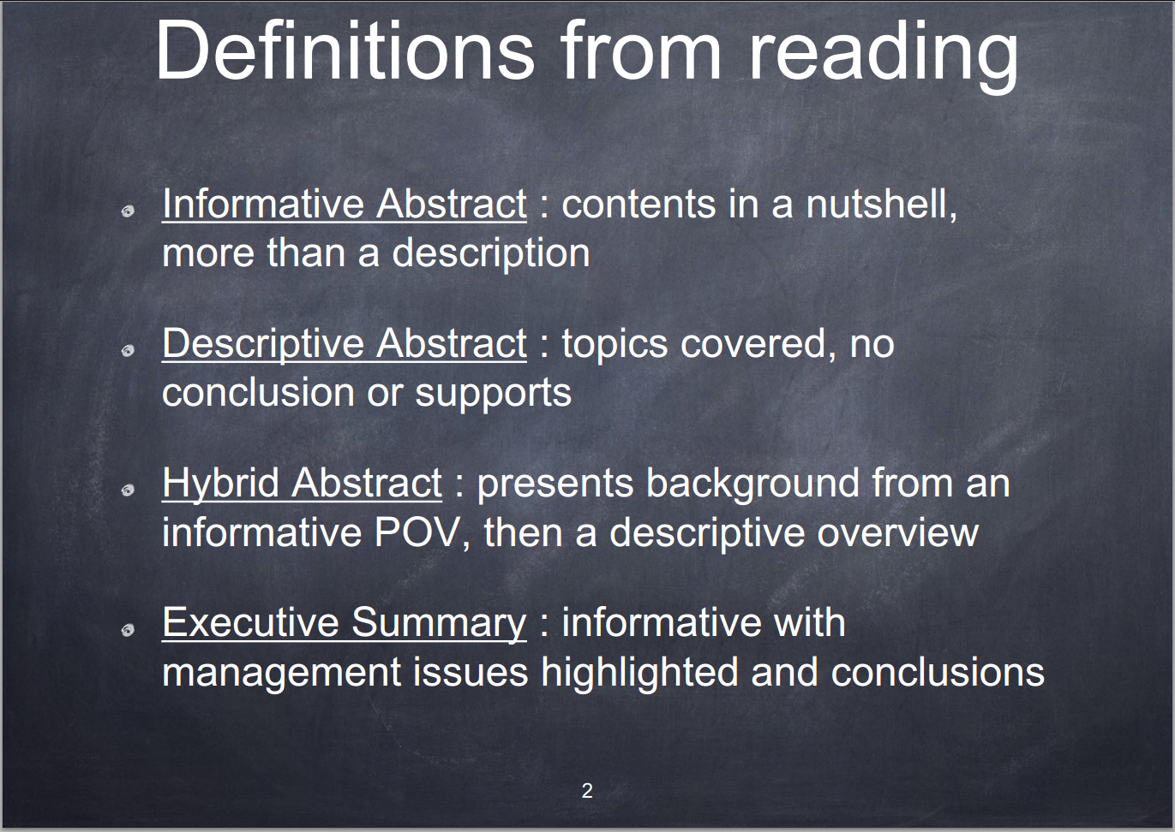

Objective writing 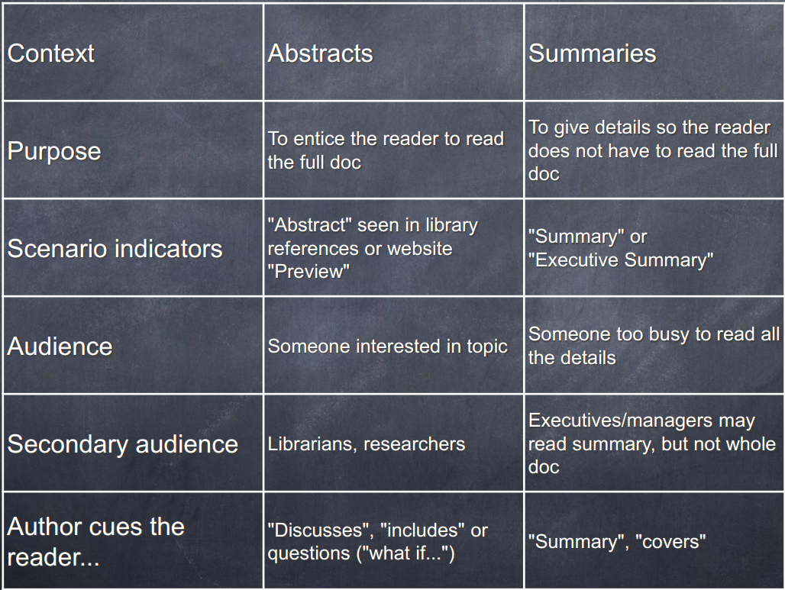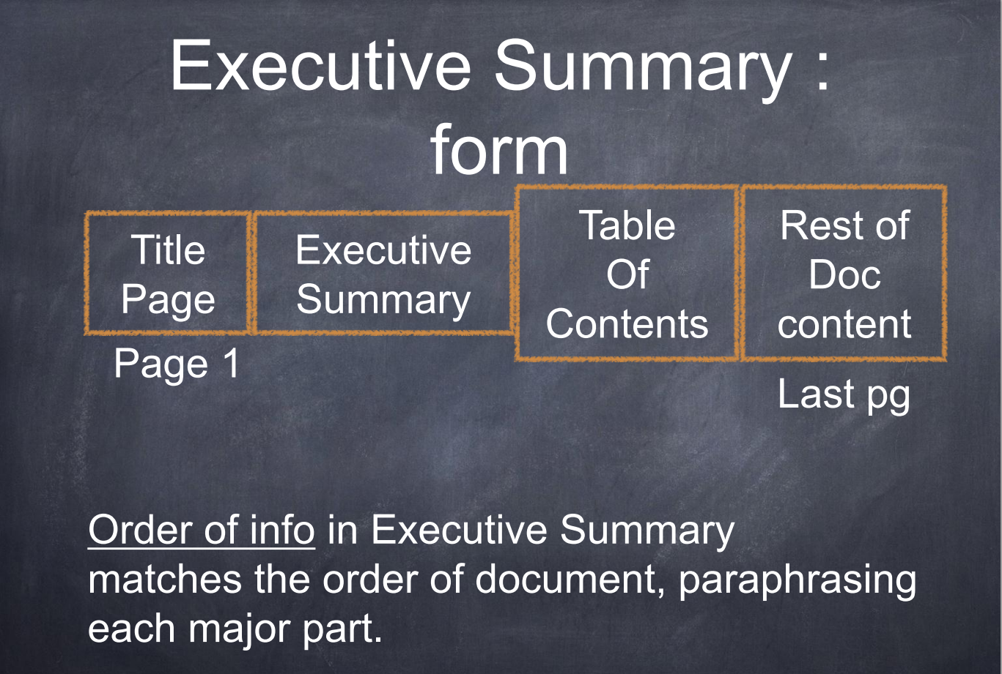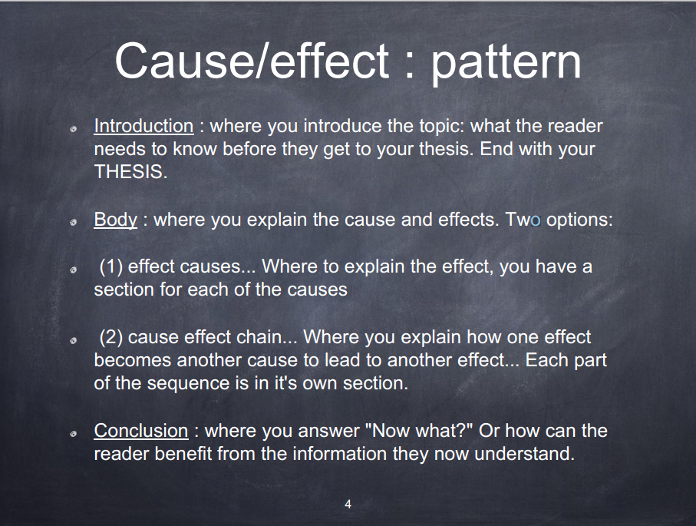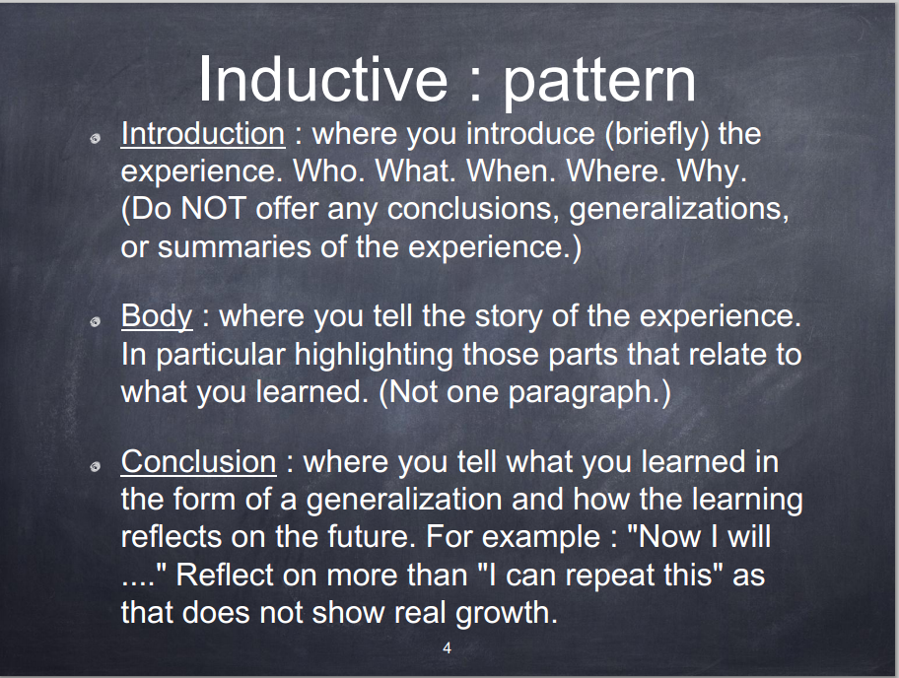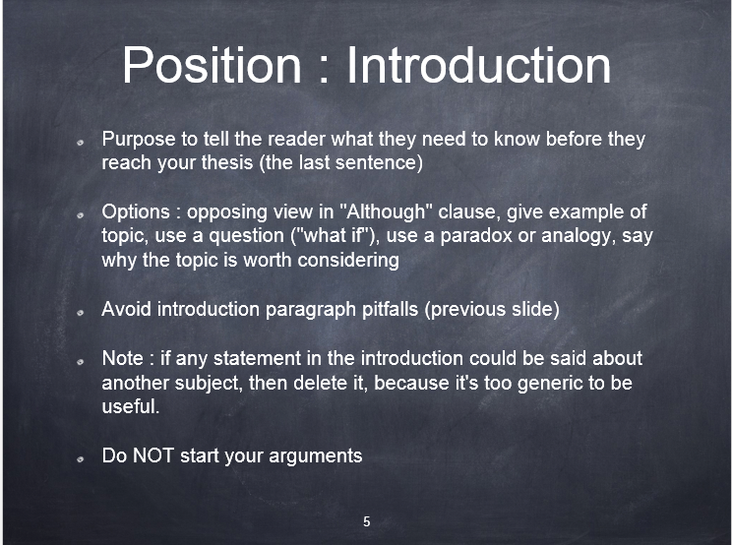

Position Conclusion: “Now what?”

To: New Gamers at UWBFrom: Odiscious Doziercc: Professor Laurie Anderson, Ph.D.

Date: July 21 , 2014

Re: Deciding between Halo 4 and Dishonored

**Compare/Contrast** INTRODUCTION

Halo 4 and Dishonored are games that can be played on a PC, but you can choose between them based on your playing preferences. The games are both highly rated; however, there are significant differences between the games. This memo is designed to help you, as a new gamer, decide which game might best fit your entertainment needs or desires. It uses the following criteria: involvement of friends, realism, environment, and story.

CONCLUSION

When selecting your next video game purchase, remember that Halo 4 and Dishonored both differ in their: involvement of your friends, realism, environment, and stories.

If you are a gamer who enjoys a stealthy single player experience, Dishonored is the clear option since Halo 4 was built for a first-person shooter experience.

If you are a gamer who enjoys a greater degree of control over the fate of your character, then Dishonored is the clear option. While Halo 4 offers stealth missions, they are minimal.

If speed and accuracy are areas of concern, you will want to purchase Halo 4. Dishonored has been built for the individual player who enjoys a slower progression through gameplay and offers minimal sniper opportunities.

**Process**

Contrast, Repetition, Alignment, and Proximity (CRAP) concepts are essential to communicating business activities and needs to the readers; therefore, here at Fully Funk-Shun-Al, we value precision and consistency when it comes to choosing and formatting a document. This chapter describes the means of deploying the most appropriate type of CRAP concepts for the given communication medium and the standards for properly formatting the document, in order to assist our editors to avoid misunderstandings or miscommunications (Williams 2008, 15 – 80).

Position

ABSTRACT

Patents are a legal and viable way innovators can document their publically or otherwise marketed products or services. With the recent boom of the Information Technology industry and the nature of it being largely conceptual, generalized or vague patents have left the market susceptible to capitalization and exploitation. This has resulted in an economic spike and government has deemed it necessary to intervene.

INTRODUCTION

Patent law was originally designed to protect the innovator from theft of concepts, goods, or services. It was also an attempt to let the general population, of the residing country, know about the existing commodity; so that, creative efforts were not frivolously spent on existing inventions.

Over the years, conceptual ideas have become a part of the business market. But, patents have not been designed with these commodities and their specific intents. This lack of exactness, has left the patent market susceptible to abuse. The most common abuse is seen from Patent Assertion Entities within patent law and the American government has not only observed the economic spike, but is moving to take governing action to either reduce or eliminate the threat to homogeneous patent law activity. These increased patent law suits are responsible for the intervention of government, in American business innovation ("Patent Assertion and US Innovation").

Problem/Solution

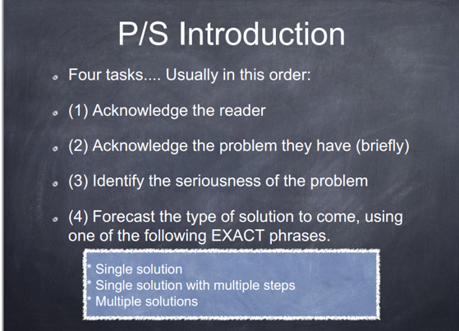

Today American student have ample access to computers at school. The problem is that many schools purchase computers assuming that having computers in the classroom will enhance students’ educations by giving them the technical skills that employers want. However, schools fail to take into account their teacher’s lack of experience using technology as a tool for teaching (Gordon).

The purposeless purchase of technology for the American classroom is a problem that needs to be addressed. This problem needs to be solved because the presence of computers in the classroom without teachers who are equipped to effectively use classroom technology is a waste of school resources and does not benefit students.

Technology can be successfully integrated into the classroom. The sections that follow outline multiple solutions to the problem.